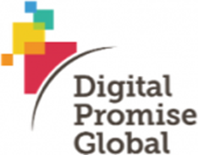
Digital Promise Global aims to spur innovation in order to improve the opportunity to learn around the world, through technology, research, and collaborative partnerships with global educators, researchers, and entrepreneurs. As our world continues to grow more complex and interconnected, one critical aspect of improving learning opportunity is enabling the development of the skills to collaborate and communicate across borders, and to critically and creatively solve problems as engaged citizens. We envision a world where all students are “globally connected learners,” using technology and digital media in powerful and authentic ways to address challenges with peers around the world.

EdSurge is an independent information resource and community for everyone involved in education technology. We report on the latest news and trends in the edtech industry to help entrepreneurs, educators and investors. In additional to reporting on trends, we share information available jobs, opportunities and events. We are also building a database of rich information about over 1,200 emerging products and how they're used. We also run a series of edtech Summits where educators and entrepreneurs meet on common ground to exchange feedback.

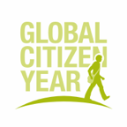
Global Citizen Year is an award-winning, non-profit social enterprise forging a new educational pathway for America’s emerging leaders. By immersing a diverse corps of fellows in developing countries during a bridge year after high school, we prepare them for success in college, careers and our global economy. We envision a world in which this bridge year becomes a common expectation and opportunity—transforming education, and unleashing the potential of our next generation as social innovators and global citizens.

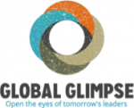
Global Glimpse is a fast growing 501c3 not for profit organization working to inspire America's next generation to become responsible and successful global citizens through after school programming and an immersion experience in the developing world. The high school program develops global competence, civic engagement, leadership, and college readiness, inspiring and empowering youth to become agents of change in their local communities and in the greater global community. Global Glimpse has grown seven fold since launching in 2008; we currently partner with over 50 public high schools in the Bay Area and New York to serve 750 majority low income students annually and are expanding to serve 1500 annually be 2017.

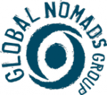
Global Nomads Group (GNG) fosters dialogue and understanding among the world’s youth. Operating at the intersection of global and peace education, GNG’s virtual exchange programs serve as a vehicle for awareness, bridge the boundaries of cultural misconceptions, and instill in our audience a heightened appreciation and comprehension of the world in which they live. GNG’s programs are rooted in a Project Based Learning curriculum that prepares students with 21st century competencies, such as cross-cultural communication and collaboration, empathy and critical thinking, in order to interact effectively with their peers from around the world. Programs are accompanied by a teacher professional development workshop that trains educators to facilitate cross- cultural dialogue, opening their classroom to international, multicultural perspectives.

iEARN-USA is a founding member of the iEARN global consortium of local NGOs, affiliated partners and universities, government representatives and educators working together to establish the field global K-12 collaborative project-based learning. The mission of iEARN-USA is to enable young people worldwide, working in collaboration and dialogue, to make a meaningful contribution to the health and welfare of the planet and its people.

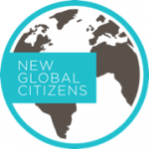
New Global Citizens is a non-profit organization that activates individuals to use their knowledge and skills to impact the global community. New Global Citizens offers classroom curriculum, professional development trainings, and afterschool programs to empower teachers and enable students to develop skills in global competency, critical thinking, collaboration, communication, digital literacy, and leadership.

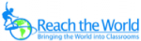
Reach the World's vision is to build a pipeline of globally competent students and educators who will succeed in and steward the 21st Century global community. RTW’s programs transform the energy of college study-abroad travelers into a teachable resource for the classroom. Through RTW, educators select a world traveler to match with for a semester. Educators map their curriculums, and select travelers whose college majors, background and personal interests are a close fit. Then, through a Standards-based program of web-based correspondence, videoconferencing and collaborative projects, students go on virtual journeys with their travelers – and expand their worldview, skills and aspirations in the process. RTW also delivers geography instruction via GeoGames, a geography learning curriculum developed by RTW, National Geographic and Columbia University Teachers College. Have you traveled? Has anyone shared their travel stories with you? Has this affected your worldview? If you can answer “Yes” to any of these questions, then you understand the mission of Reach the World. View your curriculum through a global lens. Take your classroom on the road with Reach the World!
TakingITGlobal (TIG) empowers youth to understand and act on the world’s greatest challenges. Often described as a "social network for social good," the tigweb.org online community is available in 13 languages and offers a diverse set of resources and action tools to inspire, inform and involve youth in positive social change. TakingITGlobal for Educators (TIGed) connects more than 4,000 schools in over 140 countries, providing school certification and accredited professional development to support educators in fostering global citizenship among their students. Our Sprout social innovation program offers training courses and events for aspiring social entrepreneurs, with partnerships connecting graduates to mentorship and seed funding.
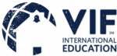
VIF International Education builds global education programs that prepare students for success in an interconnected world. For more than 25 years, educators have leveraged VIF’s professional development and curriculum, language acquisition and teacher exchange programs to generate engaging learning environments where students can excel in core curriculum as well as develop valuable critical and creative thinking skills. A certified B Corp and ‘Best for the World’ honoree headquartered in Chapel Hill, N.C., VIF provides a pathway for teachers, schools and districts to become globally designated.

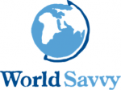
World Savvy is a national education nonprofit that addresses the need for global competence by partnering with educators, schools and districts to integrate thehighest quality of global competence teaching and learning into K-12 classrooms, so all young people can be prepared to engage, succeed, and meet the challenges of 21st citizenship. Together, Teachers College, Columbia University, World Savvy, and Asia Society launched the Global Competence Certificate, a 15-month, online program designed specifically for in-service educators who are interested in embedding global learning into their teaching practice, and preparing their students for the global reality beyond the classroom.

